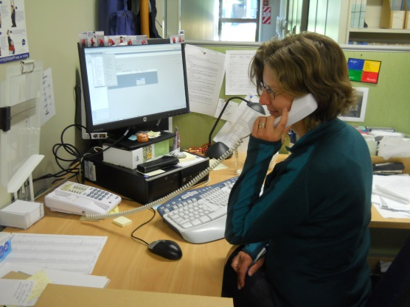
In memory of Hazel Broadbent McKenzie 1976 –2014
To be able to be as effective as Hazel was takes being a very special and talented person. Clearly Hazel could do a range of different things and do them well. Her field experience provided a strong basis for her work with the data that results. She was extremely well-organised and an amazing multi-tasker. She set a high standard and worked to a high standard herself. She had a strong vision of the new directions we should be taking. She never shied away from stretching herself and learning new things, whether it was giving her first talk at a professional meeting, running a workshop or learning SQL(Structured Query Language, this is a database programming language, Greek to most of us!). She had a very strong service ethic. Hazel was one of those people who could be absolutely trusted to do her job even better than expected. And she was an extremely pleasant person to interact with; she always approached problems in a calm, measured way. Nick Spencer, our informatics specialist, told me that no matter how much stress he put her under, she always responded cheerfully and with a smile.
At the same time as keeping NVS organised, Hazel was also involved with many other projects, particularly field work with a native carbon offset program, a nationwide survey of dead wood (logs not people!), and at Hinewai understanding how forest develops through gorse. Larry Burrows said that she was one of those fantastic people to have in the field. She could be recording 3 different types of data at once, her records were always immaculate and in her quite way she managed to keep everyone else on track to complete the job.
Hazel’s commitment to her work was evident through the various phases of her illness, Hazel continued to come into work whenever she could – which was often! She was open about her health situation, which made things easier for us. All of the NVS team were extremely impressed with her ongoing commitment to NVS, her positive attitude and very much appreciated the help and advice she continued to give us as long as she was able.
The NVS team is a tight-knit group who enjoy working together and are deeply committed to a common goal. Hazel’s loss leaves a big gap. At the same time, she is with us every day in the legacy she has left for us -- the systems and instructions she left for us that help us to carry on. I still feel like I wouldn’t be surprised to see her sitting in her chair helping Margaret or answering someone’s question over the phone. I also know that wherever she is now she is working towards what she believes in and in her no-fuss manner is helping others find what they need so that they can reach their goals as well.

